**Multi-Label Emotion Recognition from Text**

**Overview:**

The Multi-Label Emotion Recognition from Text project focuses on building an advanced system capable of detecting multiple emotions simultaneously from textual data. Unlike traditional sentiment analysis, which often classifies text into simple categories like positive, negative, or neutral, this project aims to identify a range of emotions such as joy, sadness, anger, and fear. The system will be trained on real-world datasets and optimized to handle the complexities of multi-label emotion classification. This technology can be beneficial in various domains, including customer feedback analysis, social media monitoring, and mental health applications.

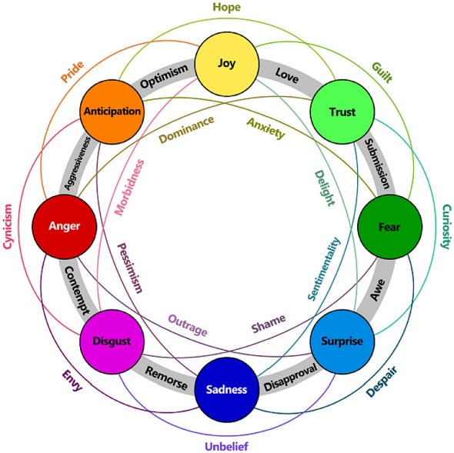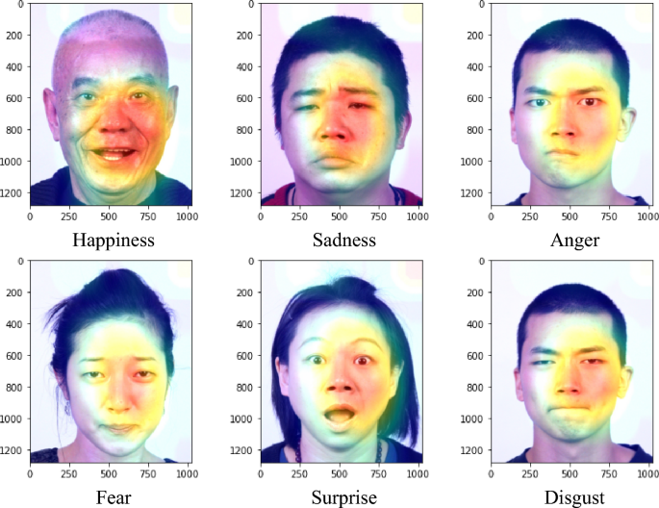

**Objectives:**

* **Dataset Processing:** Utilize the **GoEmotions Dataset by Google**, ensuring proper cleaning, tokenization, and handling of imbalanced data.
* **Model Development:** Fine-tune a **transformer-based model like BERT** to accurately classify multiple emotions present in a single text.
* **Evaluation & Optimization:** Assess the model’s performance using key metrics such as **Hamming loss, F1 score, and precision-recall curves**, refining it for improved accuracy.
* **Real-World Testing:** Apply the model to real-world datasets, such as **customer reviews, social** media posts, and user-generated content, to analyze its practical effectiveness.

Outcome: The project will result in a **robust emotion recognition system** that can identify and classify multiple emotions in a given text, improving sentiment analysis applications across various industries.

**Dataset: “GoEmotions Dataset”**

**We can download the dataset directly using dataset library ……………….**

**Where is the dataset downloaded from?**

* The dataset is hosted on Hugging Face Datasets Hub.
* Running load_dataset("go_emotions") will automatically fetch it from Hugging Face and store it in the local cache (~/.cache/huggingface/datasets).

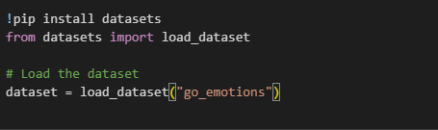

**Libraries**

What libraries that we used in this project actually.

from datasets import load_dataset

import re

from transformers import AutoTokenizer

import matplotlib.pyplot as plt

from collections import Counter

from sklearn.utils.class_weight import compute_class_weight

import numpy as np

import torch

…………………………………………………………………………………………………………………………………………………………………

**Models**

Fine-tune a transformer model such as BERT for multi-label classification.

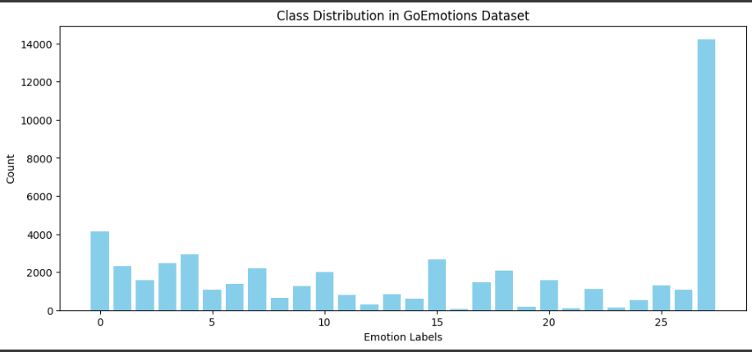

**Environment:**

Google colab

**Project Access**

**Google colab link :**

<https://colab.research.google.com/drive/1TiOYATDdT6k93p6TIBFyNv8OHUDoBXl4?usp=sharing>